SREEPATHY INSTITUTE OF MANAGEMENT & TECHNOLOGY, VAVANOOR, PALAKKAD- 679533
SPORTS AND GAMES 2015-16
Sports and games play an important role in instilling the values of discipline, self-confidence, responsibility, accountability, sacrifice and dedication, within the student. At this esteemed institution, we believe in all round development of students and hence, apart from our success stories in the field of education, the college provides encouragement and support to sports in a big way.
Our college has excellent infrastructure for sports and games with one of the best athletic grounds. Our facility includes 2 badminton Courts, Cricket net practice, Football Field, Volley ball Court, Table Tennis,10 Chess boards 200 Meters Athletic Track.
SELECTION TRIALS COLLEGE TEAMS
As a part of selection process of the college teams for participating in the Calicut University Inter-collegiate competitions, selection trials were conducted for Football, Cricket, Badminton, Chess, Volleyball and Table Tennis.

BADMINTON TEAM (MEN) (Calicut University)
1 | Midhun manmadhan .K | B.Tech, S7 ME
2 | Akash.R | B.Tech S3 ME
3 | Harikrishnan. P. R. | B.Tech S3 ME
4 | Ajay Sakariya | B.Tech S5 EEE
5 | Syam | Shyam S5 EEE

BADMINTON TEAM (WOMEN) (Calicut University)
1 | Haritha.P | B.Tech, S5, EEE
2 | Harsha.M.S | B.Tech, S7, CSE
3 | Sreebhadra.S | B.Tech, S3 CE
4 | Geethu.E | B.Tech, S7 ME
5 | Praisy C. Sunny | B.Tech, S5 CSE

CRICKET TEAM (MEN) (Calicut University)
 | Name | Branch, Class
1 | SRINATH.A | CE,S7
2 | ADITHYAN.S | ME,S3
3 | NITHIN.CM | CE,S5
4 | GOPEEKRISHAN.J | EC,S3
5 | RANJITH SANKAR | ME,S3
6 | VIPIN.AG | CE,S5
7 | ASLAM.T | CSE,S5
8 | SHYAM MOHAN.M | ME,S3
9 | ANANDHU.VP | ME,S7
10 | SHABEER BABU | CSE,S3
11 | ABDU SAHAD | CE,S5
12 | SREERAG | CE,S3
13 | HARIPRASAD.TR | CE,MTECH
14 | RANJISH.K | CSE,S3
15 | RAJEEV.KR | EEE,S3

FOOTBALL TEAM (MEN) (Calicut University)
S.No | Name | Branch, Class
1 | SREERAG.T.P | CE, S7
2 | JITHINDAS.P.M | CSE, S7
3 | RIX.T.RAJAN | ME, S5
4 | NITHIN.P.N | EC, S5
5 | ARAVIND.P.H | ME, S3A
6 | REZIN.E | CE, S3
7 | MIDHUN.K | ME, S3A
8 | VISHNU.P.U | ME, S3B
9 | SUKRUTH.P.S | CSE, S5
10 | VISHNU PRIYAN.K.V | ME, S5
11 | ABDUL SAMAD ABDUL KADER | ME, S3A
12 | ARJUNAN.K | ME, S3A
13 | VISHNU.K | CSE, S5
14 | ABDUL BASIL.M | CE, S7
15 | NAVANEETH SURESAN.A | ME, S3B
16 | MADANSANDU.MM | EC, S7
17 | NAHAS.PM | ME, S7
18 | KRISHANAPRAKASH.KU | ME, S5

VOLLYBALL TEAM (MEN) (Calicut University)
 | Name | Branch, Class
1 | MIDHUN MANMADHAN.K | B.TECH S7 ME
2 | ANANDU.V.P | B.TECH S7 ME
3 | SUDHEEP.K | B.TECH S7 ECE
4 | DHANIL.V.P | B.TECH S7 ECE
5 | ARJUN.T | B.TECH S7 ECE
6 | NITHIN.P.N | B.TECH S5 ECE
7 | JITHIN DAS | B.TECH S7 CSE
8 | SRINATH.A | B.TECH S7 CE
9 | SANTHOSH.V | B.TECH S7 CE
10 | NITHIN.C.M | B.TECH S5 CE
11 | VIPIN.A.G | B.TECH S5 CE
12 | AKASH.R | B.TECH S3 ME

CHESS TEAM (MEN) (Calicut University)
 | Name | Branch, Class
1 | ARUN.T.S | ME
2 | SURAJ RAJAN | ME
3 | SURAJ I V | CE
4 | SREEJIT | ME
5 | VISHNU.A | ME

BEST PHYSIQUE TEAM (MEN) (Calicut University)
S.No | Name | Branch, Class
1 | REESHITH THILAK.T | ME,S8

Calicut University Inter collegiate Chess Tournament
The college team has participated in the Calicut University Inter collegiate Chess Tournament held at SNDPYSS Perinthalmanna from 28th to 30th of September 2015.The College team with their brilliant performance attained 6th position and Suraj Rajan is selected to the Calicut University team.

Calicut University Inter collegiate Football Tournament
The college team has participated in the Calicut University Inter collegiate C-Zone football tournament held at M.E.S college Mannarkad from 30th September 2015.The college team won two matches and qualified to the pre-quarter final.
Calicut University Inter collegiate C-Zone Cricket Tournament
The college team has participated in the Calicut University Inter collegiate C-Zone Cricket Tournament held at S.N.G.S College Pattambi from 14th October 2015 to 19th October 2015.Our college team won two matches and reached the pre –quarter level.
Calicut University Inter collegiate C-Zone Badminton Tournament
The college Shuttle Badminton team has participated in the Calicut University Inter collegiate C-Zone Badminton Tournament held at NSS College, Palakkad on 9th and 10th of September 2015. Our college Men team won two matches and reached the Semi Finals level. Our college Women team won two matches and reached the Quarter Finals level
Calicut University Inter collegiate C-Zone Volleyball Tournament
The college Volleyball team has participated in the Calicut University Inter collegiate C-Zone Volleyball Tournament held at V.V. College, Chullimada, Kanjikkode Palakkad on 23rd and 24th of September 2015. Our college team won two matches and reached the pre –quarter level.

Calicut University Inter collegiate athletic meet-2015-16

Our college Athletic team participated in the 45th Calicut University Inter Collegiate Athletic Meet organized at the Medical college ground Kozikod Conducted by St.Joseph’s College Devagiri on 2nd to 4th December 2015

1, GOPEE KRISHNAN.J - Discus throw & Shot put
2, ASLAM.T - 1500m & 5000m Race
3, RANJITH SHANKAR - 400m & 110m Hurdles
PRIVATE ENGG. COLLEGE SPORTS AND GAMES ASSOCIATION (PECSAGA)
Our college team had participated in the PECSAGA Tournaments

REPORT
SREEPATHY SPORTS AND GAMES 2015-16
The first meeting of Sports and Games-2016 was held on 25/01/2016. The participations were decided as department wise and the whole first years were treated as AS&H Dept. So there were six teams for every match.
GAMES 2016
The games items were cricket, volley ball, football for boys and badminton for both boys and girls.
Games – Winning Champions & Runner Ups…
Sl No | Game | Winners | Runners Up
1 | Cricket | CSE | ME
2 | Football | ECE | CSE
3 | Volleyball | CE | AS&H
4 | Badminton (Men) | ME | AS&H
5 | Badminton (Women) | ME | EEE

Best Players (Games):
Cricket – SHABEER BABU.RV; S6 CSE
Football – MADHAN SANDU S8 ECE
Volleyball – NITHIN C.M; S6 CE
Badminton (Men) – MIDHUN MANMMADHAN.K.S8 ME
Badminton (Women) – GEETU; S8 ME

ANNUAL ATHLETIC MEET 2016
A meeting was arranged by committee and decided to conduct athletic meet on 05/03/2016. Staff in charge from all departments attended the meeting. Duties and responsibilities of each department were distributed. The track events were 100m, 200m, 400m, 800m and 4x100m relay for both boys and girls and 1500m for boys only. The jumping events were long jump for boys and girls and Triple jump for boys. The throwing events were shot-put for boys and cricket ball throw for girls. Discus and Javelin throw for boys only.
On 05/03/2016 the inaugural ceremony started with March-past. Dr. S.P.Subramanian (Principal, SIMAT).welcomed the gathering and presidential address was given by Dr.Thankachan (HOD, EEE Dept.) The function was inaugurated by Mr.Krishnankutty (SI Chalissery Police station) the lightening “DEEPASIKHA” were done by Dr. S.P.Subramanian (Principal, SIMAT).The oath was taken by Mr.Midhun Manmadan (General Sport’s captain). Sri.T.Ratheesh (Asst.professor,Physical Education) delivered the vote of thanks. The meet started with 1500m race. The students participated with enthusiasm. The support of non participating students and faculties made the sports meet a great memorable day.
Athletics - Champions
Individual Champion (Men) – Aslam.T; S6 CSE
Individual Champion (Women) – Jansi.PP; S6 EEE
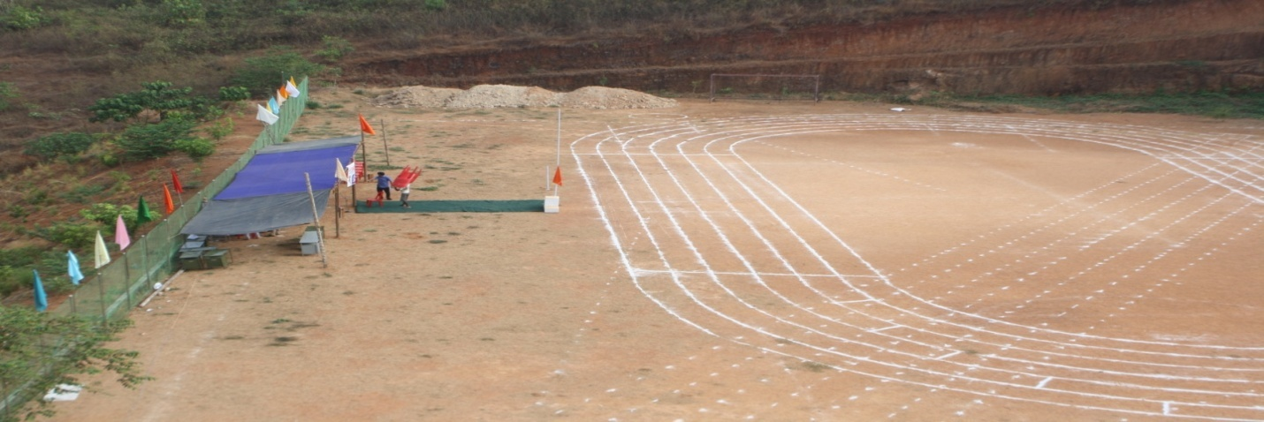

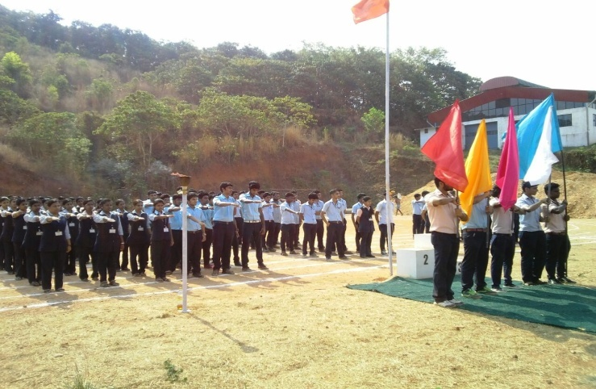
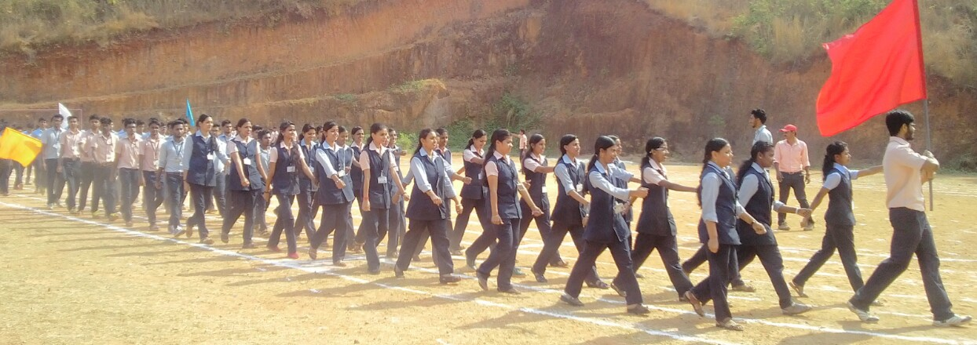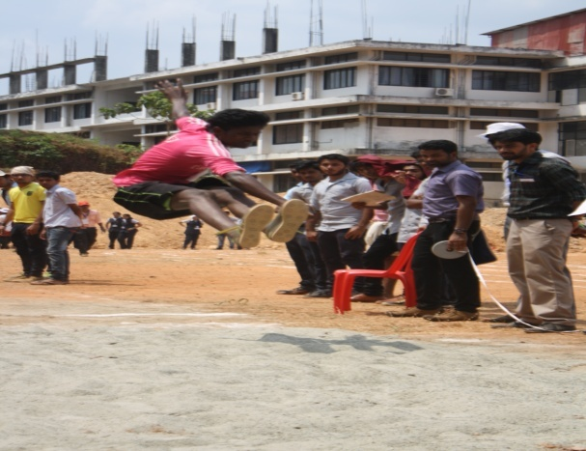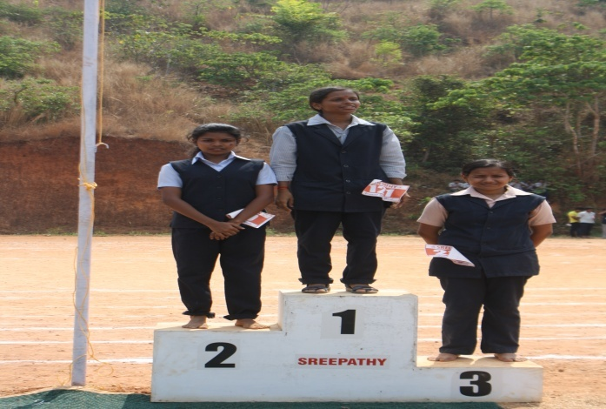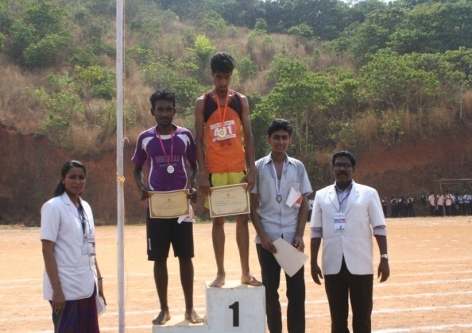
The March-past trophy was awarded to CE Dept.
The overall champions of SIMAT SPORTS AND GAMES 2016 were AS&H Dept, with 163 points and Runners up were ME Dept, with 131 points. Ever rolling trophy for the overall winners was given by Principal. The management provided refreshments to all students, teaching and non-teaching faculties. The Sports committee thanked all the staff and volunteers who rendered their great support and cooperation for the success of SIMAT SPORTS 2015-16.

Prepared by
Ratheesh.T
Assistant Professor, Physical Education
SIMAT, Vavanoor

