SREEPATHY INSTITUTE OF MANAGEMENT & TECHNOLOGY,
VAVANOOR, PALAKKAD- 679533
SPORTS AND GAMES 2018-19
Sports and games play an important role in instilling the values of discipline, self-confidence, responsibility, accountability, sacrifice and dedication, within the student. At this esteemed institution, we believe in all round development of students and hence, apart from our success stories in the field of education, the college provides encouragement and support to sports in a big way.
Our college has excellent infrastructure for sports and games with one of the best athletic grounds. Our facility includes 2 badminton Courts, Cricket net practice, Football Field; Volley ball Court, Table Tennis, 10 Chess boards 200 Meters Athletic Track.
SELECTION TRIALS COLLEGE TEAMS
As a part of selection process of the college teams for participating in the KTU Inter-collegiate competitions, selection trials were conducted for Football, Cricket, Badminton, Chess, Volleyball and Table Tennis.

CRICKET TEAM (MEN) (KTU)
 | Name | Branch, Class
1 | RAHUL.PR | CE S5
2 | SYAMJITH.M | ME S5
3 | ARSHAD.KP | ME S5
4 | SONU K UNNI | CSE S5
5 | AKSHAY.P | ME S3
6 | MAHESH MANOHARAN | CE S7
7 | MOHAMMED HASHMIL | ME S5
8 | SARATH NAMBIAR.T | ME S5
9 | NEERAJ.T | CE S1
10 | SREEJITH.S | CE S7
11 | VISAK.P | EEE S5
12 | SANJAYKRISHNAN.K | ME S3
13 | SHAHID.T | CE S5
14 | SHIDHUL.C | ME S3
15 | AKSHAY.VK | CE S5
16 | MOHAMED ASIF.MA | CE S5
17 | ANIRUDH.T | ME S3

FOOTBALL TEAM (MEN) (KTU)
S.No | Name | Branch, Class
1 | ANANTHU MANIKANDAN.P | S7,ME
2 | VEERAN SHAHAS.TT | S7,ME
3 | AKSHAY.KS | S7,ME
4 | SREEKRISHNAMOHAN | S7,ME
5 | SREE RAG.TS | S5,ME
6 | LENIN CHANDRAN | S5,CE
7 | AV. NIDHAL RAZIK | S3,ME
8 | MOHAMMED HASHMIL | S5,ME
9 | SREENATH.SR | S3,ME
10 | SHAHUL HAMEED.AI | S7,ME
11 | AMEER AHAMMED.C | S1,CE
12 | HAREESH.H | S1,CE
13 | NAKUL.U | S5,EEE
14 | AKHIL.M | S5,EEE
15 | VISHNU.MD | S7,CSE
16 | ABIJITH.G | S5,ME

VOLLYBALL TEAM (MEN) (KTU)
 | Name | Branch, Class
1 | MUHAMMED RIYAS.VK | S7,ME
2 | RANJITH.K | S7,CE
3 | VINAY | S7,CE
4 | GOPIKRISHNAN.P | S7,ME
5 | REHFIL SHAREEF | S7,CE
6 | NAVANEETH.G | S5,ME
7 | ABHINAND.PS | S1,ECE
8 | ABHISHEK.R | S1,ME
9 | KR.NITHUL KRISHANA | S1,EEE
10 | SREEHARI.MK | S3,CE
11 | RAHUL RAJAN | S3,EEE

VOLLYBALL TEAM (WOMEN) (KTU)
 | Name | Branch, Class
1 | NEETHU.TP | S7, CE
2 | VISMAYA.MV | S5,CSE
3 | AKHILA.VIJAYAN | S5,CSE
4 | VISMAYA RAVI | S5,CSE
5 | SNEHA.S | S5,CSE
6 | ASWANI.R.CHANDRAN | S5,CE
7 | SILPA.AP | S5,CE
8 | SINDHOORI.AS | S5,ECE
9 | RESHMA.A | S7,ECE
10 | ANUSHA.N | S3,CE
11 | ANJANA VINOD | S3,CE
12 | SNEHA.P | S1,CSE

CHESS TEAM (MEN) (KTU)
 | Name | Branch, Class
1 | K.PRIYADARSHAN | S1,ECE

ATHLETICS TEAM (MEN) (KTU)
S.No | Name | Branch, Class
1 | MOHAMMED HASHMIL | S6,ME
2 | RAHUL.PR | CE S5
3 | AFSAL | CE S5
4 | PRANAV.P.NAIR | S4,EEE

APJKTU Inter collegiate E-Zone Chess Tournament
The college team has participated in the KTU Inter collegiate Chess Tournament held at JCET Lakkidi, Palakkad from 12th and 13th of September 2018.Only one student is participated and he is attained 7th position in the Individual championship.

APJKTU Inter collegiate E-Zone Football Tournament
The college team has participated in the KTU Inter collegiate E-Zone football tournament held at GEC Palakkad from 20th to 23th October 2018 .The college team won two matches and qualified to the Quarter final.

APJKTU Inter collegiate E-Zone Cricket Tournament
The college team has participated in the KTU Inter collegiate E-Zone Cricket Tournament held at GEC Thrissur from 19th to 26th November 2018.Our college team reached the pre –quarter level.
APJKTU Inter collegiate E-Zone Volleyball Tournament
The college Volleyball team has participated in the KTU Inter collegiate E-Zone Volleyball Tournament held at GEC THRISSUR on 12th and 13th of September 2018. Our college Men team won one match and reached the pre –quarter level. Women team won the two matches and reached the Semi-Final level and attained 4th Position.

APJKTU Inter collegiate athletic meet-2018-19

KTU Inter Collegiate Athletics Meet 2018-19 REPORT

In the First APJKTU Inter collegiate Athletics Championship held at Kerala University Stadium Thiruvananthapuram on 2nd ,3rd,and 4th November 2018. Out of the total 1701 students from 104 colleges participated SREEPATHY Institute of Management and Technology Vavanoor attained 28th Position in Overall championship.

Individual Performance

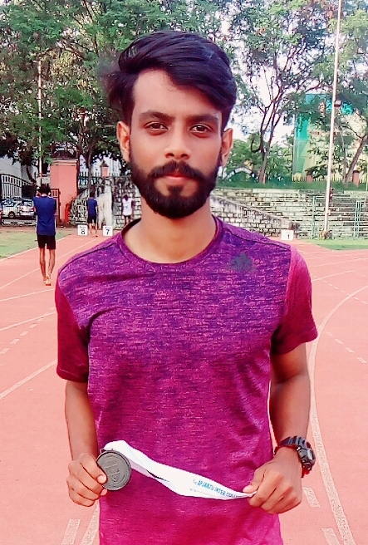
MUHAMMED HASHMIL…. S6 ME
(400m Bronze Medal, 100m 8th Position)

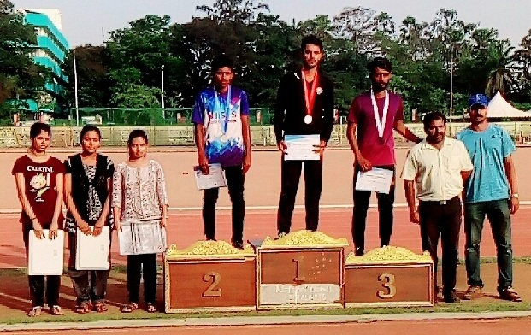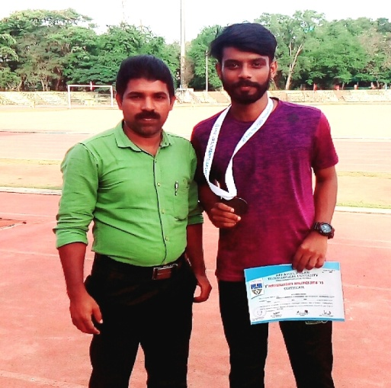

REPORT
SREEPATHY SPORTS AND GAMES 2018-19

ANNUAL ATHLETIC MEET 2018-19
A meeting was arranged by committee and decided to conduct athletic meet on 22/10/2018. All sports committee conveners attended the meeting. Duties and responsibilities of each committee were distributed. The track events were 100m, 200m, and 4x100m relay for both boys and girls 1500m for boys only and 400m walking for Girls only. The jumping events were long jump for boys and girls, Triple Jump for boys only. The throwing events were shot-put, Discus and Javelin throw for boys and cricket ball throw for girls.100m, Shot-put for Men Faculty and 100m walking, Shot-put for Women Faculty

On 27/10/2018 the inaugural ceremony started with March-past. Dr.KK BABU (Director, SIMAT).welcomed the gathering. The function was inaugurated by Mr.Manikandan (Sub.Inspector of Police Thrithla) the lightening “DEEPASIKHA” were done by Dr.KK BABU (Director, SIMAT).The oath was taken by Mr.Krishnajith (General Sports captain) delivered the vote of thanks. The meet started with 1500m race. The students participated with enthusiasm. The support of non participating students and faculties made the sports meet a great memorable day.
Athletics – Individual Champions
Individual Champion (Men) - MOHAMMED HASHMIL; S5 ME.
Individual Champion (Women) – AKHILA.T VIJAYAN; S5 CSE
Score Board
Sl.No | Department | Sports Point | Total | Position
1 | ME | 18 | 18 | I
2 | EEE | 15 | 15 | II
3 | CSE | 13 | 13 | III
4 | CE | -14 | -14 | IV
5 | ECE | -37 | -37 | V
6 | AS&H | -64 | -64 | VI

The March-past trophy was awarded to ME Dept.
The overall champions of SIMAT SPORTS AND GAMES 2019-20 were ME Dept, with 18 points and Runners up were EEE Dept, with 15 points. Ever rolling trophy for the overall winners was given by Principal. The management provided refreshments to all students, teaching and non-teaching faculties. Also mentionable is the services rendered by the NSS volunteers and the college canteen. The Sports committee thanked all the staff and volunteers who rendered their great support and cooperation for the success of SIMAT SPORTS 2018-219.
Ratheesh.T
Assistant Professor in Physical Education
SIMAT, Vavanoor

