SREEPATHY INSTITUTE OF MANAGEMENT & TECHNOLOGY,
VAVANOOR, PALAKKAD- 679533
SPORTS AND GAMES 2019-20
Sports and games play an important role in instilling the values of discipline, self-confidence, responsibility, accountability, sacrifice and dedication, within the student. At this esteemed institution, we believe in all round development of students and hence, apart from our success stories in the field of education, the college provides encouragement and support to sports in a big way.
Our college has excellent infrastructure for sports and games with one of the best athletic grounds. Our facility includes 2 badminton Courts, Cricket net practice, Football Field; Volley ball Court, Table Tennis, 10 Chess boards 200 Meters Athletic Track.
SELECTION TRIALS COLLEGE TEAMS
As a part of selection process of the college teams for participating in the KTU Inter-collegiate competitions, selection trials were conducted for Football, Cricket, Badminton, Chess, Volleyball and Table Tennis.

CRICKET TEAM (MEN) (KTU)
 | Name | Branch, Class
1 | RAHUL.PR | CE S7
2 | SYAMJITH.M | ME S7
3 | ARSHAD.KP | ME S7
4 | SONU K UNNI | CSE S7
5 | RAKESH.KK | ME,S1
6 | SHIJIL DAS.TH | CSE, S1
7 | MOHAMMED HASHMIL | ME S7
8 | SARATH NAMBIAR.T | ME S7
9 | NEERAJ.T | CE,S3
10 | ANIRUDH.T | ME S5
11 | ABHIRAMAN.M | CSE, S1
12 | SANJAYKRISHNAN.K | ME S5
13 | SHAHID.T | CE S7
14 | SHIDHUL.C | ME S5
15 | AJITH.A | ME, S1
16 | NIVED.NM | CSE,S5
17 | S.SIVAKUMAR | ECE,S7
18 | AKSHAY KUMAR.PK | EEE,S1

FOOTBALL TEAM (MEN) (KTU)
S.No | Name | Branch, Class
1 | SREE RAG.TS | ME S7
2 | SYAMJITH.M | ME S7
3 | AJAY SWAMINADHAN | ME S1
4 | SIDHARTH | ME S1
5 | AV. NIDHAL RAZIK | ME S5
6 | MUHAMMED SUFIYAN | ME S7
7 | MOHAMMED HASHMIL | ME S7
8 | AMEER AHAMMED.C | CE S3
9 | NAKUL.U | EEE S7
10 | AKHIL.M | EEE S7
11 | ABIJITH.G | ME S7
12 | JISHNU PRASAD.MB | ME S7
13 | AKASH.KP | CE S5
14 | ADARSH.KP | CE S5
15 | MOHAMMED ASHAB.KS | ME S1
16 | MOHAMMED AFSAL | CSE S1

VOLLYBALL TEAM (MEN) (KTU)
 | Name | Branch, Class
1 | AKHIL.J | S3,EEE
2 | ABHINAND.PS | S3,ECE
3 | ABHISHEK.R | S3,ME
4 | AKSHAY KUMAR.PK | S1,EEE
5 | ABIN.C | S1,CSE
6 | RAHUL RAJAN | S5,EEE
7 | VISHNU.MP | S7,EEE
8 | ABEEDAR.MA | S1,EEE
9 | SANDEEP.AS | S7,EEE

VOLLYBALL TEAM (WOMEN) (KTU)
 | Name | Branch, Class
1 | VISMAYA.MV | S7,CSE
2 | VISMAYA RAVI | S7,CSE
3 | AKHILA.VIJAYAN | S7,CSE
4 | SNEHA.S | S7,CSE
5 | RANJIMA MOHAN.P | S7,CSE
6 | SILPA.AP | S7,CE
7 | ANUSHA.N | S5,CE
8 | ANJANA VINOD | S5,CE
9 | SNEHA.P | S3,CSE

CHESS TEAM (MEN) (KTU)
 | Name | Branch, Class
1 | VYSHNAV.MP | S7,ME
2 | K.PRIYADARSHAN | S3,ECE
3 | AKHIL.V | S1,CSE
4 | YESUDAS.PY | S1,CSE
5 | HAREESH.CK | S5,ME
6 | NIYAS.MV | S1,ECE

HANDBALL TEAM (MEN) (KTU)
S.No | Name | Branch, Class
1 | NIDHEESH BABU.P | ME S3
2 | SYAMJITH.M | ME S7
3 | RAHUL.PR | CE S7
4 | ROIBAK.PV | CE S1
5 | AV. NIDHAL RAZIK | ME S5
6 | SANIL.TP | CSE S3
7 | MOHAMMED HASHMIL | ME S7
8 | SREEKRISHNAN.S | ME S7
9 | AKSHAY RAJ | ME S3
10 | SACHINRAJ.KK | ME S3
11 | VIVEK.A | ME S3
12 | ABHISHEK.R | ME S3
13 | ABHINAND.PS | ECE S3
14 | RAKESH.KK | ME S1
ATHLETICS TEAM (MEN) (KTU)
S.No | Name | Branch, Class
1 | MOHAMMED HASHMIL | S8,ME
2 | AV. NIDHAL RAZIK | S6,ME
3 | JISHNU PRASAD.MB | S8,ME
4 | PRANAV.P.NAIR | S6,EEE
5 | AKASH.KP. | S6,CE
6 | ADARSH.KP. | S6,CE
7 | VISAK.P | S8,EEE
8 | ATHUL.S | S8,EEE
9 | ABEEDAR.MA | S2,EEE
10 | NIYAS.MV | S2,ECE
11 | AKSHAY RAJ | S4,ME
12 | ANANTHA KRISHNAN.VP | S6,ME

ATHLETICS TEAM (WOMEN) (KTU)

S.No | Name | Branch, Class
1 | VISMAYA.MV | S8,CSE
2 | VISMAYA RAVI | S8,CSE
3 | SNEHA.S | S8,CSE
4 | AKHILA.T. VIJAYAN | S8,CSE
5 | KAVYA | S8,CSE

APJKTU Inter collegiate E-Zone Chess Tournament
The college team has participated in the KTU Inter collegiate Chess Tournament held at EKC Manjeri from 21th and 22th of October 2019.The College team with their brilliant performance attained 7th position. In total 18 colleges participated in the championship.

APJKTU Inter collegiate E-Zone Football Tournament
The college team has participated in the KTU Inter collegiate E-Zone football tournament held at VIDYA Engg. College Thrissur from 13th to 19th November 2019 .The college team won two matches and qualified to the Quarter final.

APJKTU Inter collegiate E-Zone Cricket Tournament
The college team has participated in the KTU Inter collegiate E-Zone Cricket Tournament held at VIDYA Engg. College Thrissur from 6th November 2019.Our college team won two matches and reached the pre –quarter level.
APJKTU Inter collegiate E-Zone Handball Tournament
The college Shuttle Badminton team has participated in the KTU Inter collegiate E-Zone Handball Tournament held at EKC Manjeri on 27th and 28th of November 2019. Our college Men team participated in this championship.

APJKTU Inter collegiate E-Zone Volleyball Tournament
The college Volleyball team has participated in the KTU Inter collegiate E-Zone Volleyball Tournament held at GEC THRISSUR on 13th and 14th of October 2019. Our college Men team won one match and reached the pre –quarter level. Women team won the one match and reached the pre –quarter level.

APJKTU Inter collegiate athletic meet-2019-20

KTU Inter Collegiate Athletics Meet 2020 REPORT

In the Second APJKTU Inter collegiate Athletics Championship held at Kerala University Stadium Thiruvananthapuram on 5th ,6th,and 7th February 2020. Out of the total 1818 students from 101 colleges participated SREEPATHY Institute of Management and Technology Vavanoor attained 13th Position in Men championship and 23rd Position in Overall championship.

Individual Performance

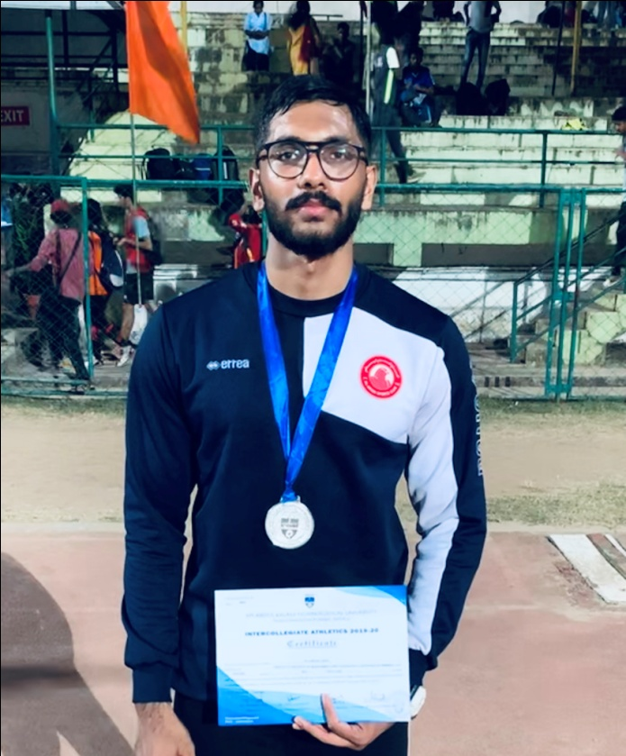
AV.NIDHAL RAZIK…. S6 ME
(Triple Jump Silver Medal & New meet Record, 4x100m Relay 6th Position)

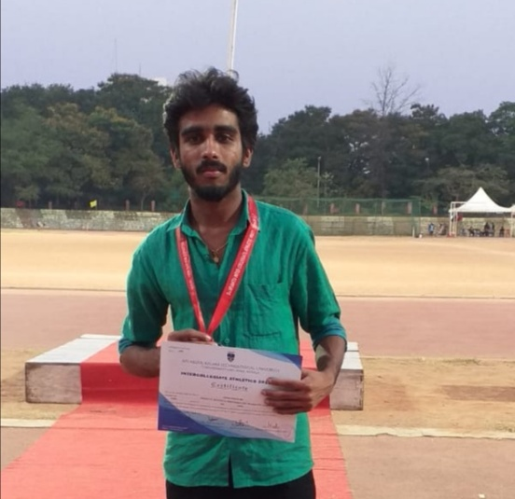
JISHNU PRASAD.MB….S8ME
(5000M Bronze Medal & New Meet Record,10000m 5th Position)

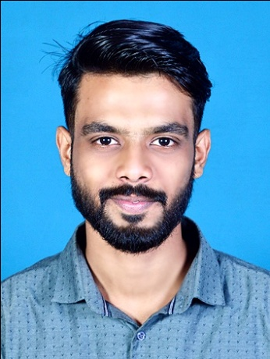
MUHAMMED HASHMIL…. S8 ME
(200m 5th Position, 400m 5th Position & 4x100m Relay 6th Position)

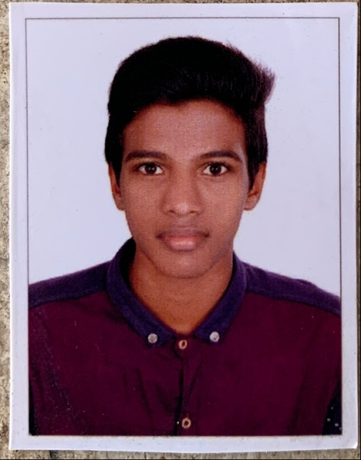
AKASH.KP….S6 CE
(High Jump 4th Position & New Meet Record)
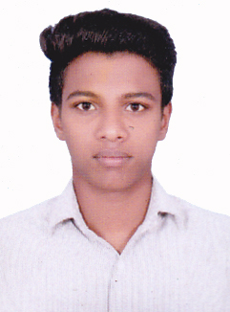
ADARSH.KP…. S6 CE
(Triple Jump 6th Position & 4x100m Relay 6th Position)

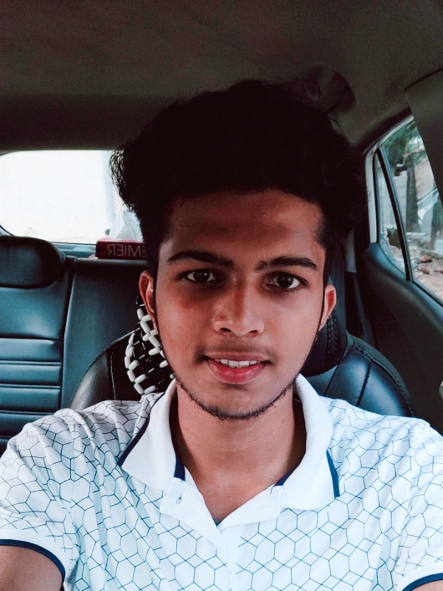
PRANAV.P NAIR…
(4x100m Relay 6th Position)

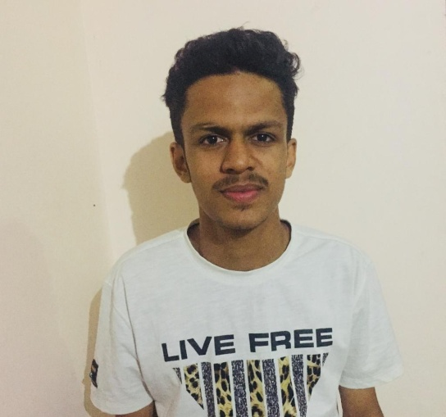
ABEEDAR.MA….S2 EEE
(110M Hurdles 7th Position)

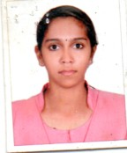
AKHILA.T VIJAYAN….S8 CSE
(1500m 8th Position & New meet Record)

REPORT
SREEPATHY SPORTS AND GAMES 2019-20
GAMES 2019-20
The games items were cricket, volley ball, football for boys and badminton for both boys and girls.
Games – Winning Champions & Runner Ups…
Sl No | Game | Winners | Runners Up
1 | Football | ME | AS&H
2 | Volleyball | ME | EEE
3 | Badminton (Men) | ME | AS&H
4 | Badminton (Women) | CSE | CE

Best Players (Games):
Football –MUHAMMED SUFIYAN; S7 ME
Volleyball – AKHIL.J; S3 EEE
Badminton (Men) – SHIJIL DAS.TH; S1 CSE
Badminton (Women) – VISMAYA.MV; S7 CSE

ANNUAL ATHLETIC MEET 2019-20
A meeting was arranged by committee and decided to conduct athletic meet on 26/11/2019. All sports committee conveners attended the meeting. Duties and responsibilities of each committee were distributed. The track events were 100m, 200m, and 4x100m relay for both boys and girls 1500m for boys only and 400m walking for Girls only. The jumping events were long jump for boys and girls, Triple Jump for boys only. The throwing events were shot-put, Discus and Javelin throw for boys and cricket ball throw for girls.100m, Shot-put for Men Faculty and 100m walking, Shot-put for Women Faculty

On 19/12/2019 the inaugural ceremony started with March-past. Dr.George.CT (Principal, SIMAT).welcomed the gathering. The function was inaugurated by Dr.KN.Thrivikraman (Chairman Sreepathy Trust) the lightening “DEEPASIKHA” were done by Dr.KN.Thrivikraman (Chairman Sreepathy Trust) and Sri. KH.Parameswaran. (Secretary Sreepathy Trust) and Prof.Thankachen.PV (HOD EEE) did the felicitation. The oath was taken by Mr.Akhil.J S3 EEE(Volleyball Player 2019-20). Mr.Visak.P(General Sports captain) delivered the vote of thanks. The meet started with 1500m race. The students participated with enthusiasm. The support of non participating students and faculties made the sports meet a great memorable day.

Athletics – Individual Champions

Individual Champion (Men) – MUHAMMED SUFIYAN; S7 ME &

MOHAMMED HASHMIL; S3 ME.

Individual Champion (Women) – SHINCY.TU; S1 CE
Score Board

Sl.No | Department | Games Point | Sports Point | Total | Position
1 | ME | 30 | 77 | 107 | I
2 | AS&H | 10 | 19 | 29 | II
3 | CE | 5 | 15 | 20 | III
4 | EEE | 5 | 4 | 9 | IV
5 | ECE | 0 | -2 | -2 | V
6 | CSE | 10 | -13 | -3 | VI
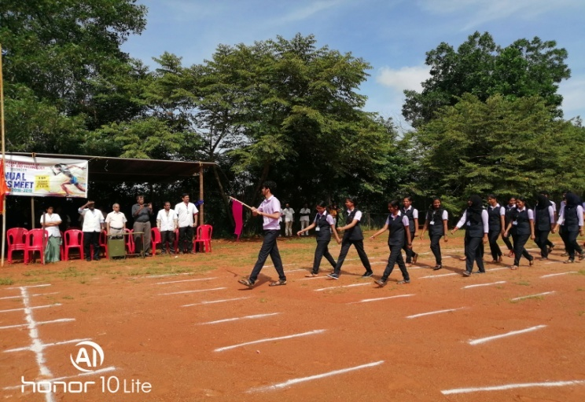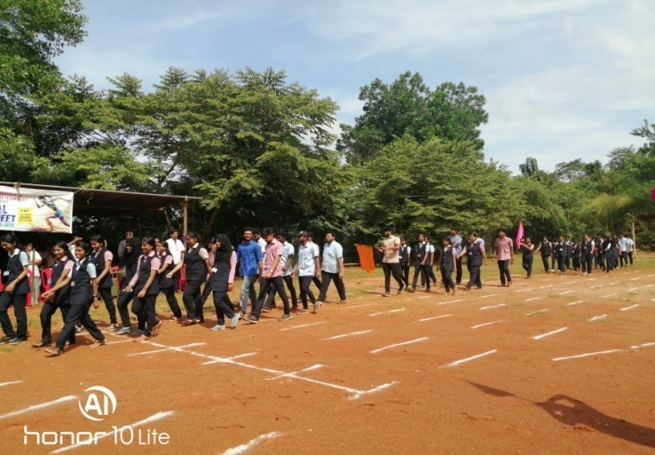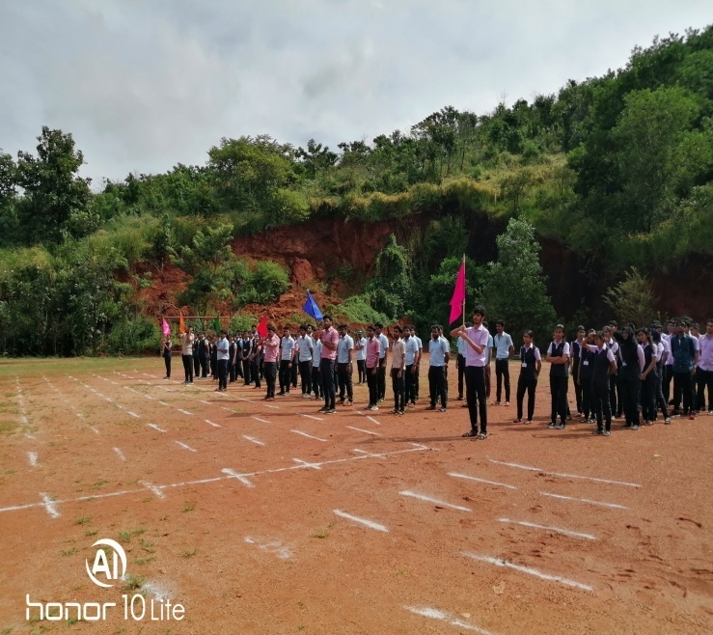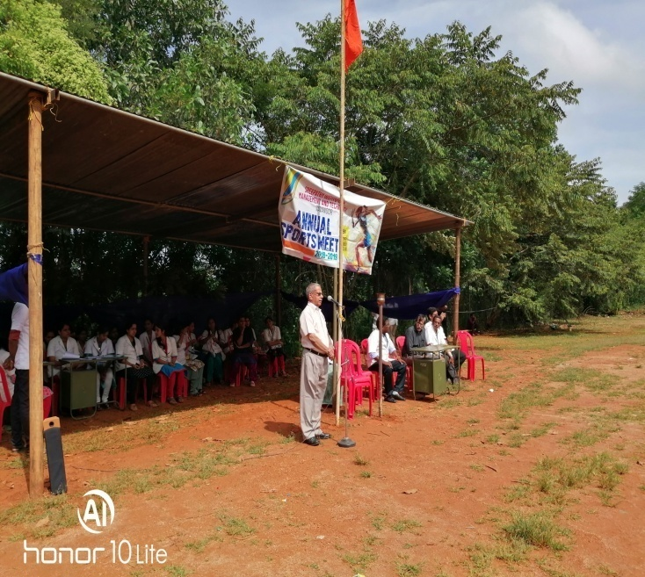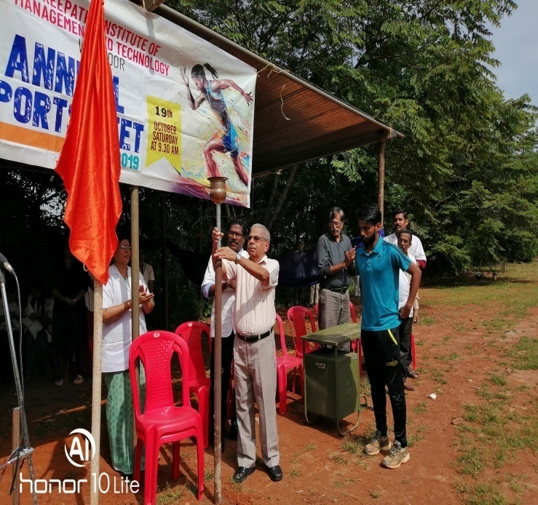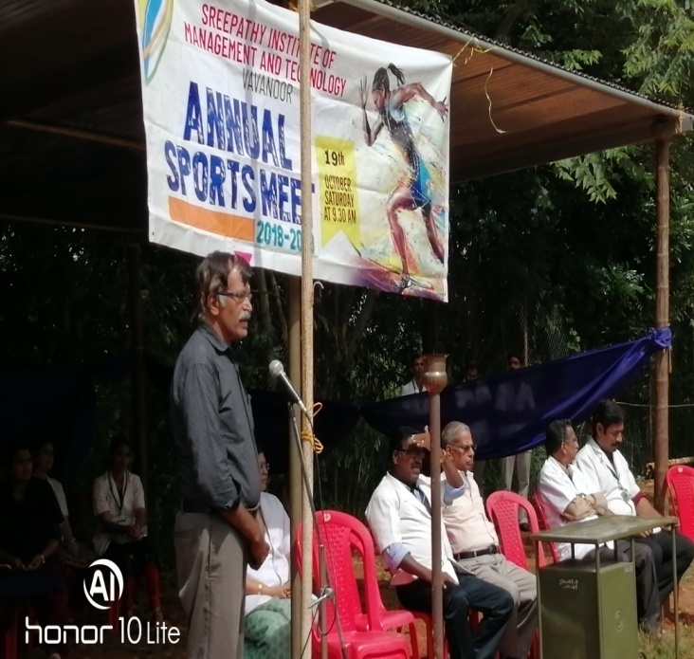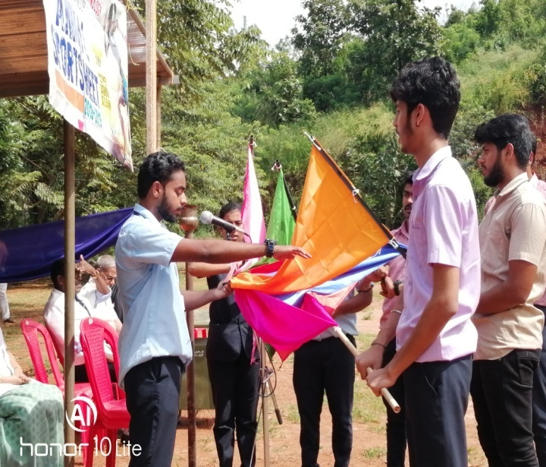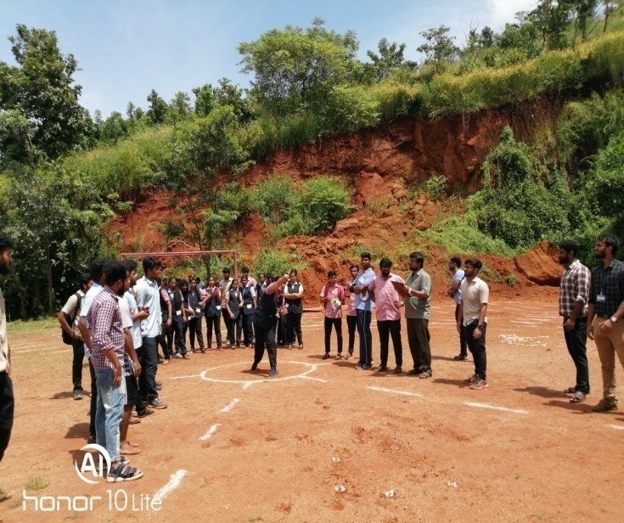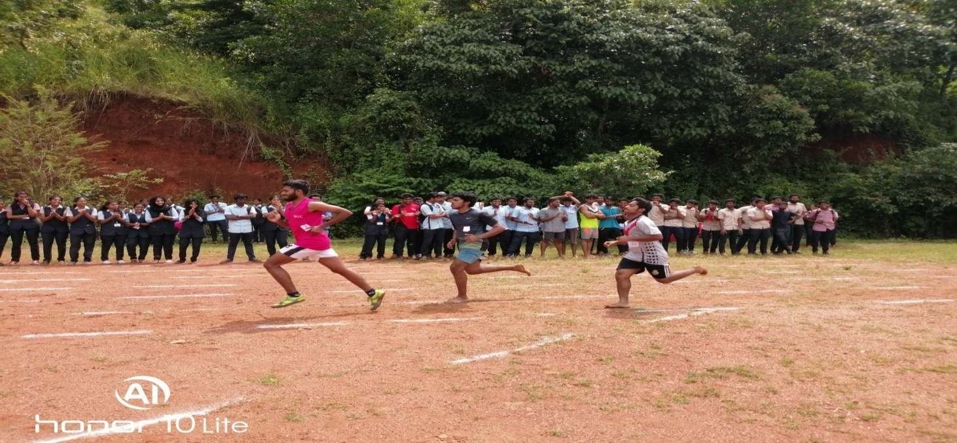
The March-past trophy was awarded to AS&H Dept.
The overall champions of SIMAT SPORTS AND GAMES 2019-20 were ME Dept, with 107 points and Runners up were AS&H Dept, with 29 points. Ever rolling trophy for the overall winners was given by Principal. The management provided refreshments to all students, teaching and non-teaching faculties. Also mentionable is the services rendered by the NSS volunteers and the college canteen. The Sports committee thanked all the staff and volunteers who rendered their great support and cooperation for the success of SIMAT SPORTS 2019-20.
Ratheesh.T
Assistant Professor in Physical Education
SIMAT, Vavanoor

