SREEPATHY INSTITUTE OF MANAGEMENT AND TECHNOLOGY (SIMAT)
Vavanoor, Palakkad - 679 533
SIMAT/ACAD/P/19/133 25/09/2019
Circular
Congratulations
As per the rank list published by the University, the following students are ranked in 2014-2018 Batch.

Sl No | Dept | Name | Photo | CGPA | Rank
1 | CE | SREELAKSHMY C | 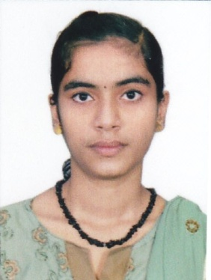 | 8.84 | 7
2 | CE | MANEESHA K S | 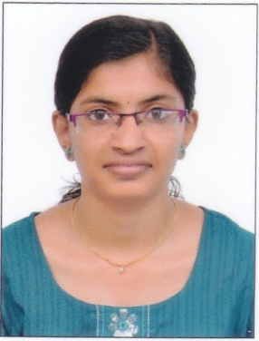 | 8.77 | 10
3 | CE | CHAITHRA R |  | 8.59 | 22
4 | CE | SREELAKSHMI N |  | 8.57 | 23
5 | CE | MANJUSHA A V |  | 8.47 | 31
6 | CE | ELWIN P SAJAN | 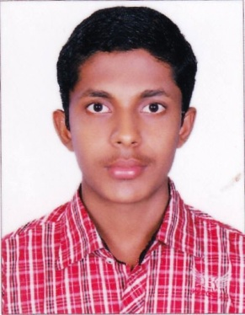 | 8.25 | 48
7 | CE | ARJUN M P | 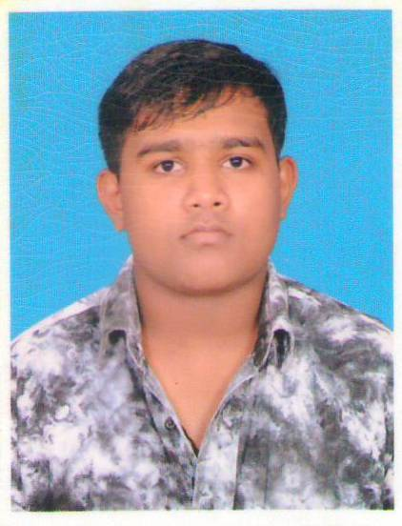 | 8.23 | 50
8 | CE | PRAJITHA P MENON |  | 8.17 | 55
9 | CSE | AMRITHA SETHU | 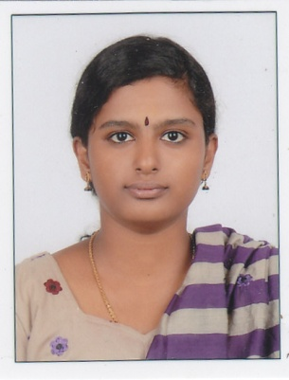 | 8.45 | 17
10 | CSE | ASWATHY T K |  | 8.31 | 29
11 | ECE | SARANYA MOHAN | 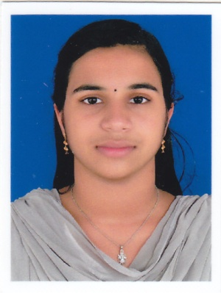 | 8.47 | 16
12 | ECE | AYANA MOHAN V M | 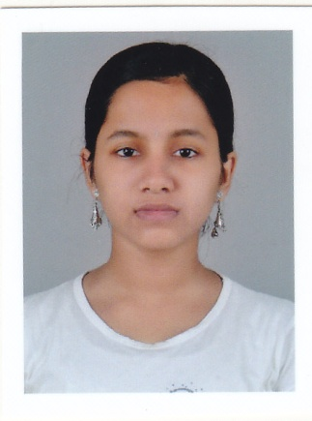 | 8.22 | 35
13 | ECE | SREELAKSHMI V S |  | 8.22 | 35
14 | ECE | SMRITHY K S | 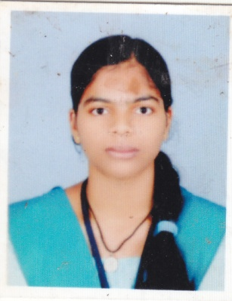 | 8.14 | 43
15 | EEE | KANNAN S |  | 8.91 | 5
16 | EEE | SARANYA K P | 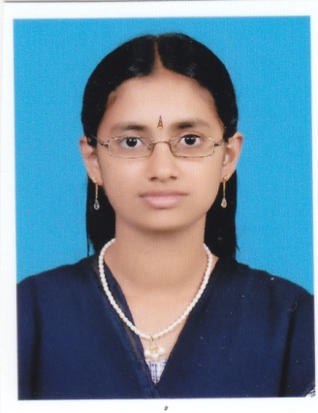 | 8.71 | 7
17 | EEE | MOHAMED SHANAB V V | 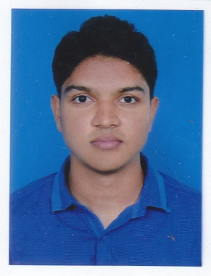 | 8.26 | 32
18 | EEE | NISHAD UL HAQ |  | 8.20 | 38
19 | ME | SHYAM MOHAN | 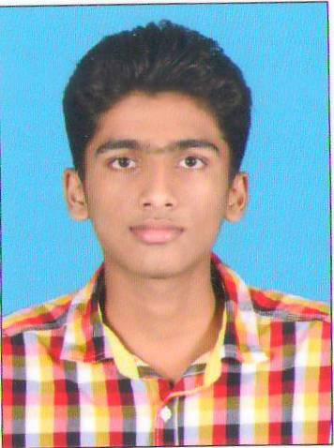 | 8.68 | 12
20 | ME | ABHILASH N N | 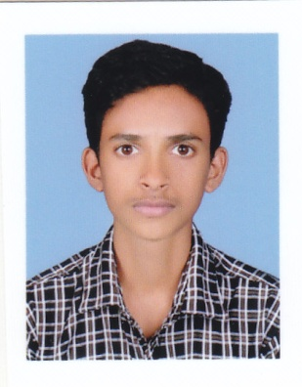 | 8.51 | 24
21 | ME | ANANTHA PADMANABHAN M | 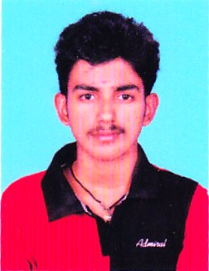 | 8.21 | 47
22 | ME | VYSHNAV A | 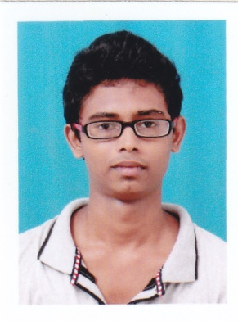 | 8.18 | 49
23 | ME | SOORAJ V T |  | 8.14 | 52
24 | ME | NIKHILDAS M P |  | 8.05 | 60
25 | ME | HEMANTH M P |  | 8.03 | 62
26 | ME | SARATH C | 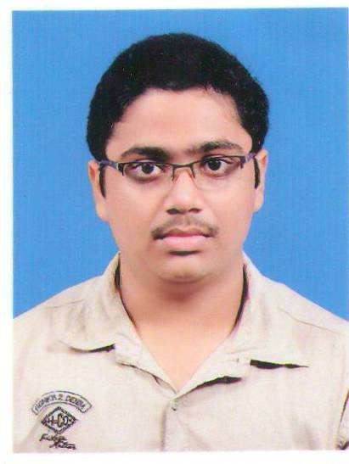 | 8.00 | 65

Principal
Copy to:-
- All Staff
- Mgmt

