SREEPATHY INSTITUTE OF MANAGEMENT AND TECHNOLOGY (SIMAT)
Vavanoor, Palakkad - 679 533
SIMAT/ACAD/P/15/241 10/12/2015
Circular
SUB: - GREAT ACHIEVEMENTS
SREEVIDHYA C V, Sreepathy 2010-14 Batch student bagged Calicut University First Rank in Computer Science & Engineering Branch.

SREEVIDHYA C.V – CGPA 9.00
Congratulations
It is a great achievement to Sreepathy and let us all join in congratulating the student for her remarkable performance.
As per the rank list published by the University, the following students also are ranked in 2010-14 Batch.

Sl No | Dept | Name | Photo | CGPA | Rank
1 | CSE | ABILASHA S | 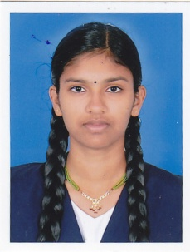 | 8.68 | 12
2 | CSE | ASWATHI SANTHOSH | 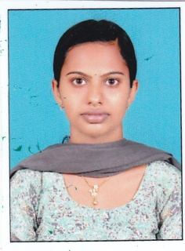 | 8.13 | 44
3 | CE | DHANESH L | 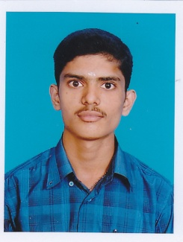 | 8.65 | 10
4 | CE | SHAJEENA K H | 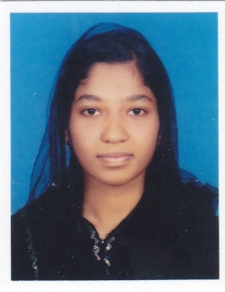 | 8.50 | 18
5 | CE | KRISHNAPRIYA P R | 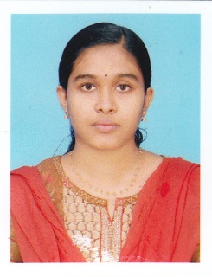 | 8.44 | 21
6 | CE | AKHILA A | 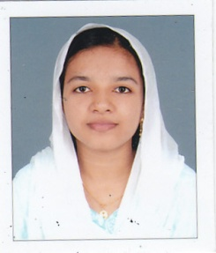 | 8.34 | 24
7 | ECE | JOSHITHA K | 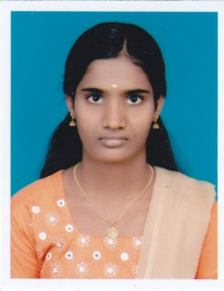 | 8.82 | 15
8 | ECE | REMYA PRABHAKARAN | 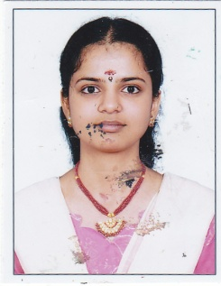 | 8.60 | 32
9 | ECE | SNEHA V V | 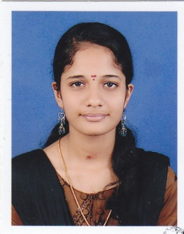 | 8.39 | 46
10 | ECE | SUSMITHA T M | 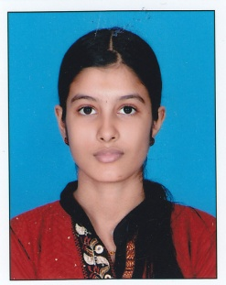 | 8.35 | 50
11 | ECE | AKHILA E T | 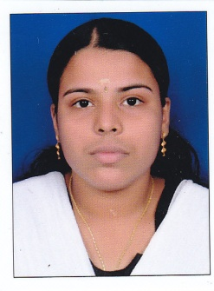 | 8.26 | 59
12 | EEE | DILEEPKUMAR C H | 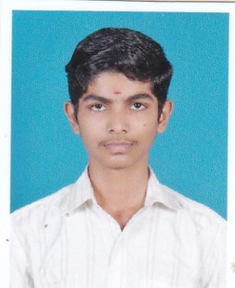 | 8.75 | 13
13 | EEE | RAJALAKSHMI P S | 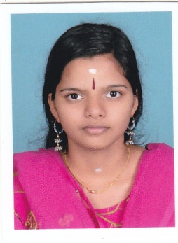 | 8.61 | 18
14 | EEE | SWATHYPRAKAH | 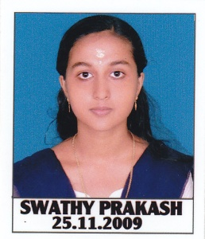 | 8.29 | 38

Principal
Copy to:-
- All Staff
- Mgmt
- Academic Council
- Mr. Ganesh – To include in website, inform students through Group SMS
- Mentors to forward to all students.

