SREEPATHY INSTITUTE OF MANAGEMENT AND TECHNOLOGY (SIMAT)
Vavanoor, Palakkad - 679 533
The position of our 2009-13 batch students in Calicut University B. Tech Degree Examination.

Sl No | Name | Branch | CGPA | University Position | Photo
1 | ASWATHI SHANMUGAN | EEE | 9.04 | 4 | 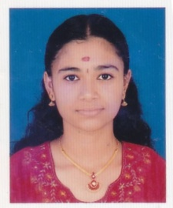
2 | HARSHA K V | EEE | 8.67 | 23 | 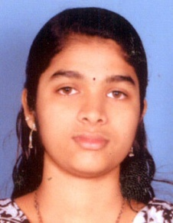
3 | VARUN K | EEE | 8.64 | 25 | 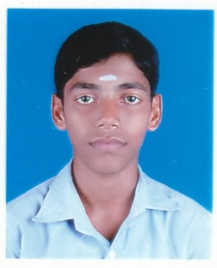
1 | SILPA P G | ECE | 8.63 | 27 | 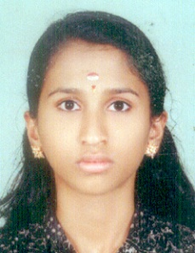
2 | SREEDEVI VALSAN K | ECE | 8.47 | 40 | 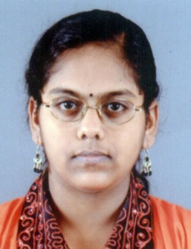
1 | HARSHA K P | CE | 8.68 | 22 | 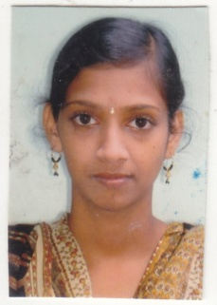
1 | ROHITH B | CSE | 8.52 | 20 | 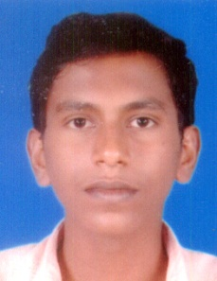
2 | THULASI P K | CSE | 8.3 | 37 | 