SREEPATHY INSTITUTE OF MANAGEMENT AND TECHNOLOGY (SIMAT)
Vavanoor, Palakkad - 679 533
The position of our 2011-15 batch students in Calicut University B. Tech Degree Examination.

Sl No | Name | Branch | CGPA | University Position | Photo
1 | RESHMA THILAK. T | CE | 8.78 | 7 | 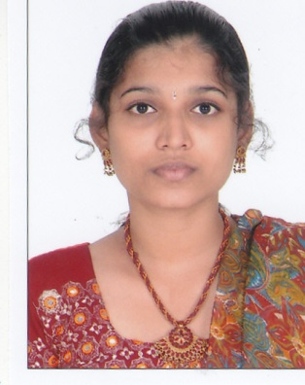
2 | MINNU UNNI | CE | 8.75 | 10 | 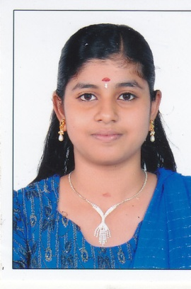
3 | ANJALI P | CE | 8.50 | 26 | 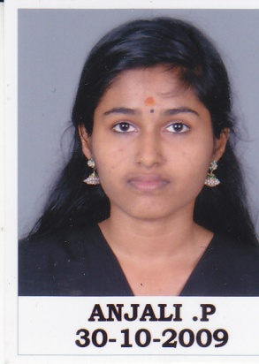
4 | K PRASEETHA | CE | 8.49 | 27 | 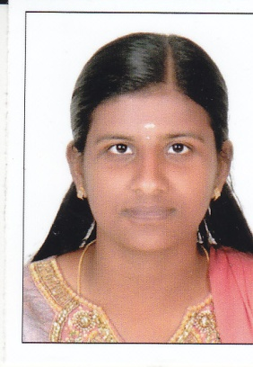
5 | RINITHA VARGHESE | CE | 8.36 | 39 | 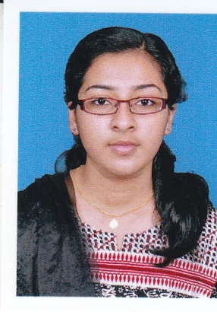
6 | ARYA M B | CSE | 8.52 | 12
7 | KRISHNAPRIYA V | CSE | 8.51 | 13 | 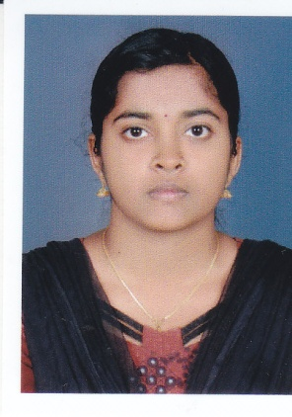
8 | SREESHA P | CSE | 8.26 | 28 | 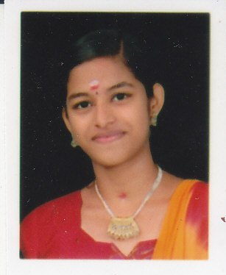
9 | JABIR K H | CSE | 8.24 | 30 | 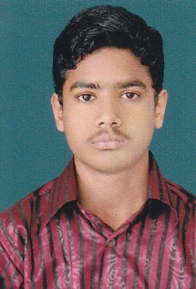
10 | VANI M E | ECE | 8.49 | 32 | 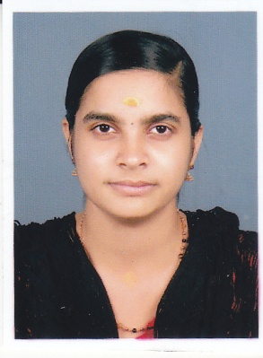
11 | ATHIRA V P | ECE | 8.24 | 55 | 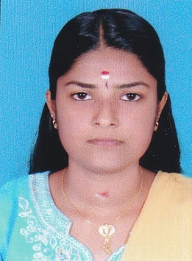
12 | JOHN N JOSE | ME | 8.30 | 31 | 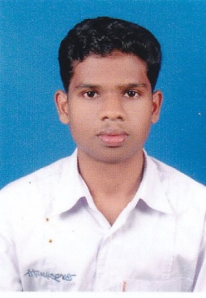
13 | K M VARUN | ME | 8.19 | 41 | 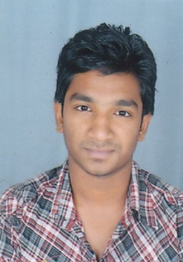
14 | SARATH BABU THEKKOOT SURENDRAN | ME | 8.16 | 44 | 