SREEPATHY INSTITUTE OF MANAGEMENT AND TECHNOLOGY (SIMAT)
Vavanoor, Palakkad - 679 533
Congratulations
The following students are ranked in 2012-16 Batch - Calicut University.
Sl. No | Dept. | Name | Photo | CGPA | Rank
1 | CE | AMRUTHA M | 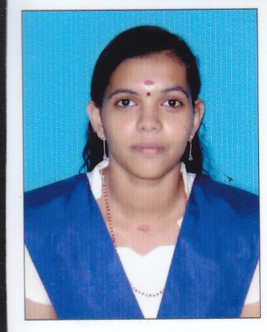 | 8.55 | 31
2 | CSE | UMA E S | 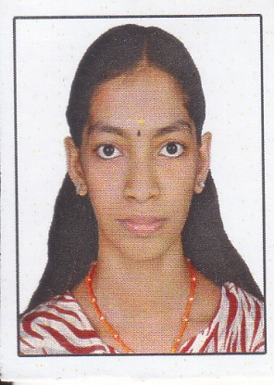 | 8.30 | 37
3 | ECE | SUJISHA V | 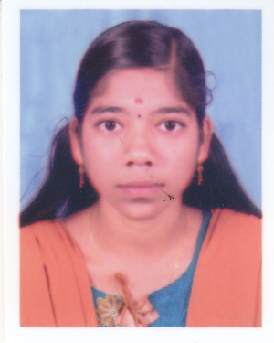 | 8.45 | 30
4 | ECE | THUSHAR K | 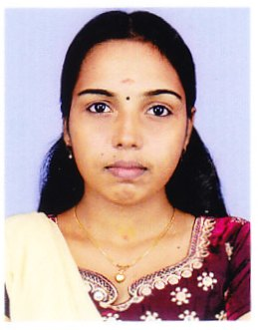 | 8.42 | 42
5 | ECE | NIVEDITHA P S | 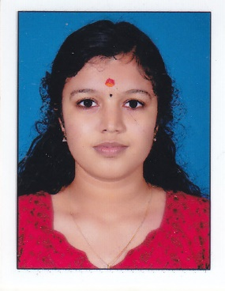 | 8.36 | 38
6 | ECE | ANJALI K M | 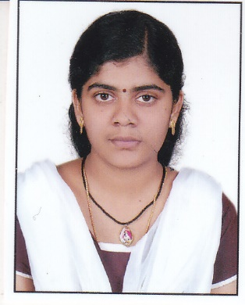 | 8.30 | 44
7 | ECE | SUSMI P S | 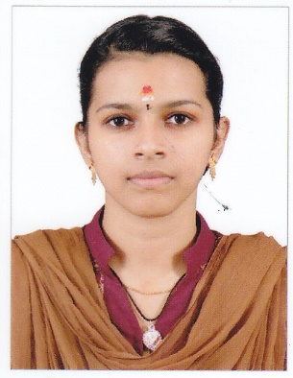 | 8.18 | 56
8 | EEE | ATHIRA M | 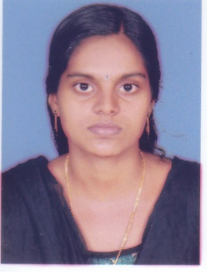 | 8.80 | 9
9 | EEE | AISWARYA M | 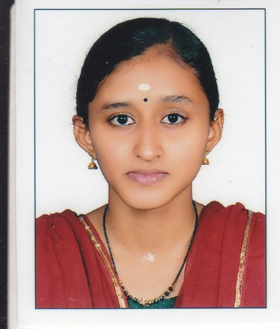 | 8.47 | 18
10 | ME | SRIHARI S | 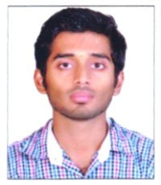 | 8.75 | 14
11 | ME | JAYAKRISHNAN S | 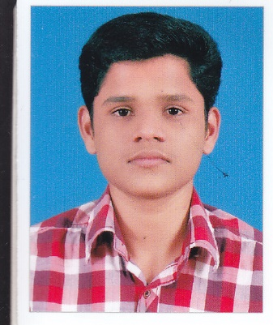 | 8.4 | 33
12 | ME | SREENATH K V | 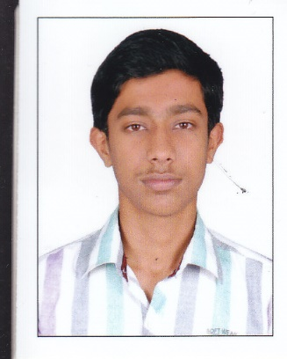 | 8.33 | 39
13 | ME | RANJITH R | 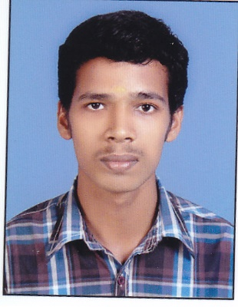 | 28.28 | 43

