SREEPATHY INSTITUTE OF MANAGEMENT AND TECHNOLOGY (SIMAT)
Vavanoor, Palakkad - 679 533

Congratulations
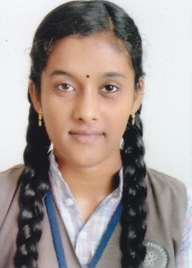

SRUTHI S – 9.46
COMPUTER SCIENCE AND ENGIEERING
FIRST RANK [2013-17]

It is a great achievement to Sreepathy and let us all join in congratulating the student for her remarkable performance.
As per the rank list published by the University, the following students also are ranked in 2013-17 Batch.

Sl No | Dept | Name | Photo | CGPA | Rank
1 | CSE | SRUTHI S |  | 9.46 | 1
2 | CSE | HARITHA C V | 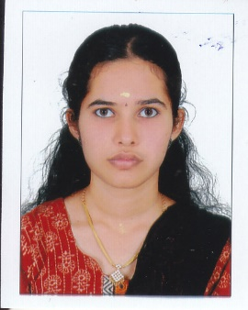 | 8.70 | 16
3 | CSE | ANUPAMA ARAVIND P | 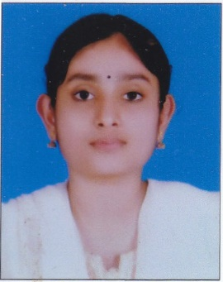 | 8.58 | 21
4 | CSE | GAYATHRI G NAIR | 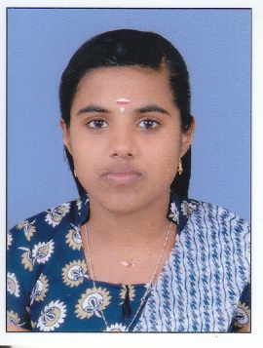 | 8.47 | 28
5 | CSE | AISWARYA K SURENDRAN | 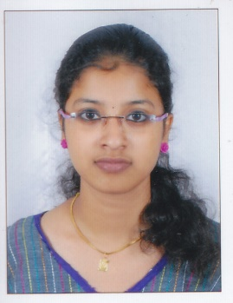 | 8.32 | 39
6 | CE | RAKENDU P S | 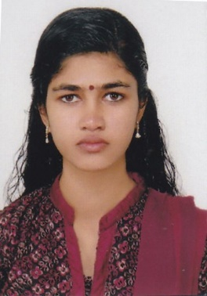 | 9.06 | 9
7 | CE | APARNA NAIR | 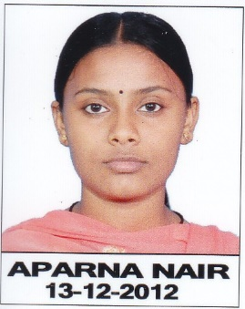 | 9.03 | 11
8 | CE | RAVIKRISHNAN C | 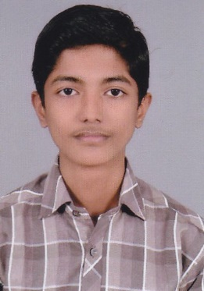 | 8.81 | 17
9 | CE | GREESHMA M K | 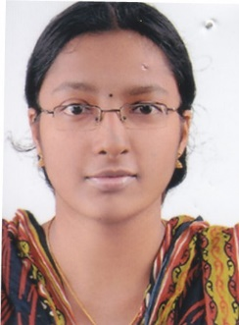 | 8.66 | 24
10 | CE | ATHIRA PREMKUMAR | 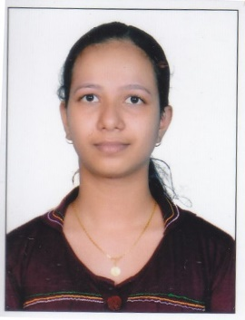 | 8.65 | 25
11 | CE | GREESHMA A P | 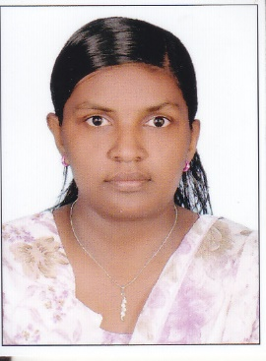 | 8.47 | 41
12 | CE | JISHA DEV V P | 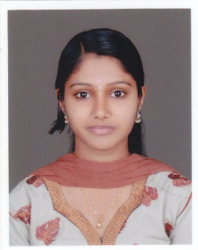 | 8.37 | 51
13 | ECE | ATHIRA A | 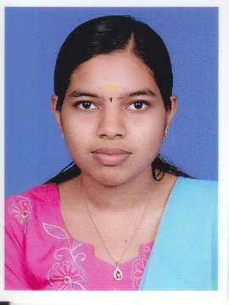 | 8.97 | 5
14 | ECE | VIDYA VIJAYAKUMAR P V | 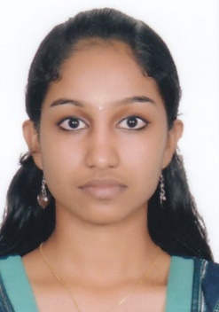 | 8.87 | 8
15 | ECE | RAJANI C |  | 8.63 | 18
16 | ECE | SILPA K P | 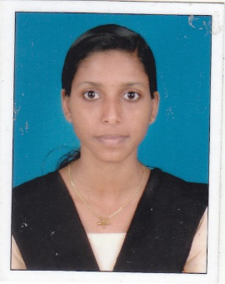 | 8.61 | 20
17 | ECE | VINEETHA K | 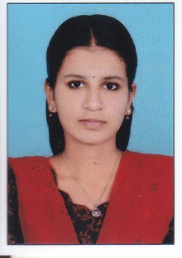 | 8.26 | 48
18 | EEE | AKHILA E M | 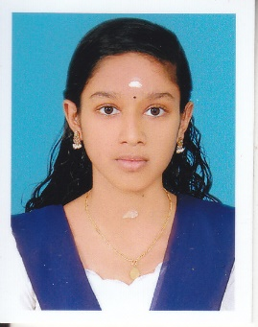 | 8.68 | 20
19 | EEE | SWETHA K | 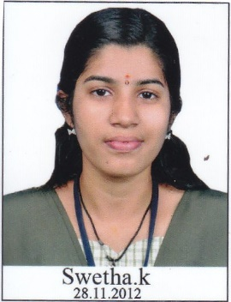 | 8.32 | 40
20 | EEE | HARITHA P | 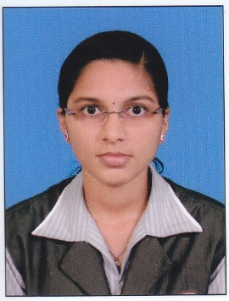 | 8.31 | 41
21 | EEE | VARSHA T | 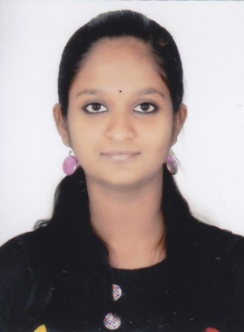 | 8.29 | 42
22 | ME | DIVYA P V | 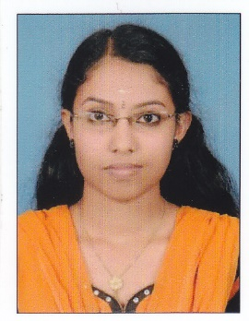 | 9.10 | 5
23 | ME | SAJEESH N | 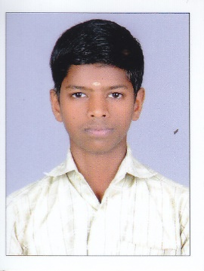 | 8.76 | 14
24 | ME | NITHIN A P | 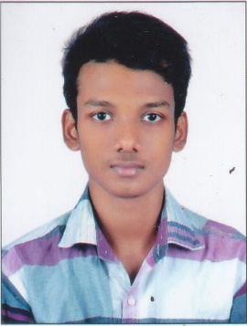 | 8.69 | 17
25 | ME | SOORAJ N P | 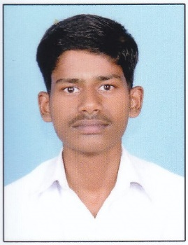 | 8.47 | 31
26 | ME | AKSHAY BALACHANDRAN | 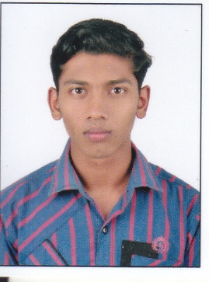 | 8.21 | 49

