SREEPTHY INSTITUTE OF MANAGEMENT&TECHNOLOGY
SARGOTSAVAM 2015
REPORT

Sreeparthy Sargotsavam was conducted successfully on 16/10/2015 & 17/10/2015.The inaugural function of the arts festival was held on 16/10/2015 at 9.30am. Famous play back Singer Mr. Anoop Sankar formally inaugurated the function. Student senate chairman Srinath A welcomed the gathering. Sreepathy Trust Chairman Shri P Sankaran Namboothiripad delivered the Presidential Address. Later the Oath taking Ceremony of Student Senate (2015-16) members was also conducted on the same day. College Principle Dr. S P Subramanian administered the oath of office to 12 Senate members. Sreepathy Trust, Director, Prof. Ajith Raja, was also present in the function. Mrs. Revathy Venu (President, PTMA. SIMAT) gave away the felicitation address. Fine arts secretary Ms. Deepthi panicker delivered the Vote of thanks. After the inaugural function the cultural competitions were started at 11.00am. All the branches were actively participated in the cultural competitions .The Department Of Electronics and Communication won the Ever Rolling Trophy of Sargotsavam.
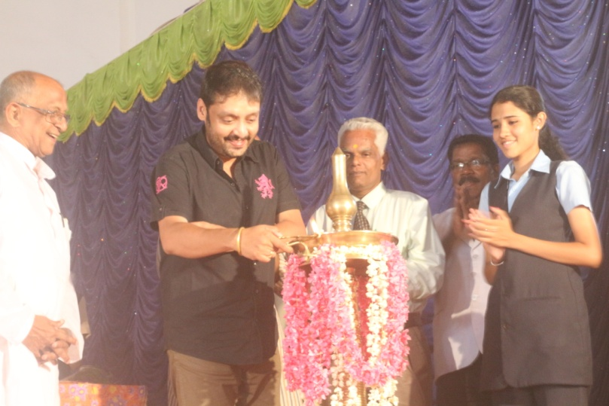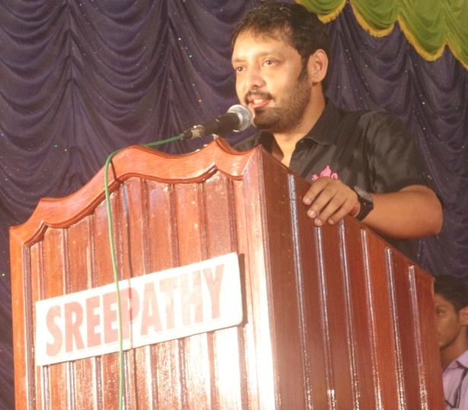
Playback singer Mr Anoop Sankar inaugurating the function Chief Guest delivering the inaugural address
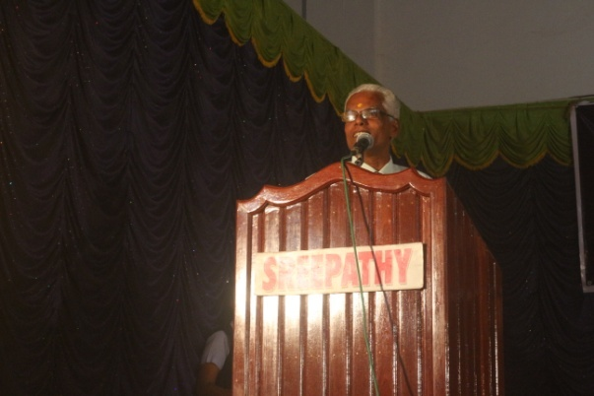
Principal Dr. S P Subramanian addressing the audience
General Coordinator
Dr. George C T (HOD, AS&H)

